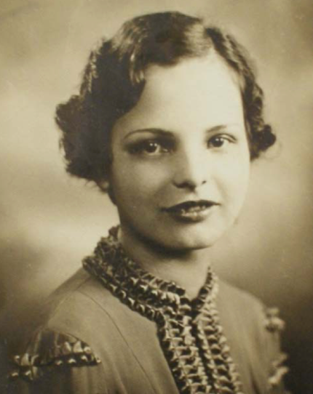

The current years’ recipients of The Josefina Aguado
Scholarship for Single Parents have been selected.

Next years’ Application will be posted in the
beginning of the year.

ELIGIBILITY

Applicants must:
- Be a single parent with children no older than 21.
- Be of Puerto Rican descent.
- Have a minimum 3.0 G.P.A.
- Be enrolled in an accredited college or university in the Fall of award year pursuing an undergraduate or graduate degree.
- Undergo a face-to-face interview with the Selection Committee.

GUIDELINES
- A completed application package must include an application form, essay, college transcripts, two letters of
- recommendation, a short biographical sketch, and a recent photo.
- All items must be submitted by email to Lisa M. Rodriguez, Co-Chair, CN Scholarship Selection Committee cn.scholarship@gmail.com, (347) 693-6893
- The 500-word essay must answer the question posed on the application
- The 500-word biographical sketch should include goals, dreams, career objectives, information about family. Any obstacles/challenges encountered as a single mother and how they have been resolved. List any volunteer community work done with responsibilities that involved the Puerto Rican community/Latino community (i.e., voter registration, census drives, neighborhood clean-up, mentoring, tutoring, youth groups, etc.
- Letters of recommendation should be requested from professors, counselors, mentors, clergy, community leaders, etc. The letters should highlight any challenges the candidate has experienced and overcome to continue their education, does the candidate do volunteer work/community service, how long has the person known the candidate, and the specific contributions the applicant has made to the community.
- Application package must be received by email by deadline date provided
- Application package emailed after deadline date provided will be disqualified.
- A mandatory personal interview will be conducted by the scholarship committee
- Finalist will be notified within two- weeks
- Finalist will not be considered if he/she does not show-up for interview. Other arrangements will be made for finalist away at college.
- Recipients of The Josefina Aguado Scholarship for Single Parents will be notified with a week after personal interview
- Recipients of The Josefina Aguado Scholarship for Single Parents will be disqualified should any of the following conditions occur:
  - (1) recipient provides false information on application;
  - (2) recipient is not enrolled in an accredited college or university by the fall or at the time if the award
  - (3) recipient is not of Puerto Rican descent.
- Scholarship payment will be made by Comité Noviembre upon recipient of official college registration or Bursar’s Office documentation.

For more information contact:
Lisa M. Rodriguez
Co-Chair, CN Scholarship Selection Committee
(347) 693-6893, cn.scholarship@gmail.com

